Fort Myer Construction Corporation

Bidding Management System

Final Systems Report

BR JAM CONSULTING (Group 2)

Rafeed Ullah | Jennifer Jung | Brian Mazzone

Anthony Falbo | Miral Ahmad | Rachana Sirigiri

**Table of Contents**

**1. Executive Summary** 2

**2. Systems Request** 3

**3. Requirements Definition and Use Cases** 5

**Section 1: Requirements Definition** 5

**Section 1.1: Interview Guide** 9

**Section 1.2: Documents/Artifacts** 11

**Section 2: Use Case Analysis** 12

**Appendix** 17

**4. Process Modeling Documentation** 23

**Section 1: Process Modeling** 23

**Section 1.1: Context Diagram** 23

**Section 1.2: Level 0 Data Flow Diagram** 24

**Section 1.3: Level 1 Data Flow Diagrams** 25

**Section 2: Data Dictionary Definitions** 30

**5. Data Modeling Document** 32

**Section 1: Developing a Data Model (ERD)** 32

**Section 2: Developing a Alternative Matrix** 33

**Section 3: Alternative Matrix 2 and Hardware/Software Specification** 34

**Section 3.1: Alternative Matrix 2 (Non-Functional Requirements)** 34

**Section 3.2: Network Architecture Selection** 35

**Section 3.3: Hardware/Software Specification** 36

**6. User Interface, Physical Process and Data Models** 37

**Section 1: User Interface Design** 37

**Section 2: Interface Design Prototypes** 38

**Section 3: Logical Level 0 DFD Model** 43

**Section 4: Physical Data Models** 44

# **1. Executive Summary**

Fort Myer Construction Corporation is a construction company that serves the infrastructure needs of the DC Metro Area. The company handles thousands of potential projects per month. Being able to bid and process as many jobs as possible directly determines the profits available to the company. This executive summary aims to provide the problem, solution and timeline/cost for this project.

The problem that Fort Myer currently faces is that their bottleneck is the amount of bids they can process at a time while still maintaining high quality work. Therefore, the most important goals associated with the business are those that allow Fort Myer to process a higher number of bids. Additional business needs include the ability to perform collaborative work, have a consolidation of tools required, and reduce the steps required to complete a bid. In addition to these needs, our client would like to continue to perform tasks securely and without any workflow performance slowdowns.

To ensure this, our IS 436 team at UMBC designed and documented an information system to process over 50 bids per day, with no downtime during a typical workday (6am-6pm). We are confident this design will meet Fort Myer’s needs and provide employees with a secure and reliable platform. This system is a custom designed solution that addresses the four non functional requirements such as operational, performance, security and cultural/political. This system would provide robust and efficient access to Fort Myer’s needs of bidding of at least 50 bids per day. This design was unanimously reached by the IS 436 team after evaluating other design solutions that include but not limited to; pre-packaged software, system revamp, Commercial Off The Shelf (COTS) and other solutions. The team decided to proceed with a custom built system that could meet Fort Myer’s needs for bidding while satisfying the requirements given by the client. In addition to efficiency, the client would receive a much better collaborative experience, this is because the custom built system focuses on the needs of the bidding management system and reduces other unwanted system processes. Other solutions such as prepackaged software would be hard to configure to meet the client needs, this could be caused by extra processes running under the “hood” that could interfere with the low latency requirement or hinder collaboration tools that are needed by the client.

While the custom built system aligns with the client’s needs the most, it still remains the most expensive solution. However, in earlier interviews and documentation it is noted that Fort Myer shows more leniency towards a better solution instead of saving costs for that system. Our implementation would have a system that would “pay for itself” by promising enhanced efficiency and minimal downtime during work hours. The system implementation aims to cost around $750,000 with a project completion time scheduled for about 12 months.

# **2. Systems Request**

**Project Sponsor**

Name: Tiago Torres Job Title: Estimator

Organization: Fort Myer Construction Corporation Contact: detiago2008@hotmail.com

**Business Need:**

Fort Myer’s primary business revolves around providing as many quality bids as quickly as possible. The estimation processes must become more efficient for project bidding for Fort Myers though the process of simplifying and streamlining the systems used. This will be a singular system that merges multiple aspects of various software to create an all inclusive specially made system for Fort Myers’ needs which will help increase their profitability and scalability.

**Business Requirements:**

* The system shall consolidate the number of applications required for a normal bidding process.
* The system shall reduce the complexity of the applications currently deployed at Fort Myer.
* The system shall attempt to minimize the downtime needed for the application.
* The system shall increase the ability to perform work collaboratively.
* The system shall have the ability to submit bids electronically and securely.
* The system shall focus to have a simple and user friendly interface
* The system shall help decrease the number of mistakes that occur during bid estimation.

**Business Value:**

- The improved system will help improve bidding and estimation process workflow by simplifying the process required to estimate and submit bids

- Save three or more hours of estimator labor hours per project per estimator

- Decrease the applications involved in the bidding process from 6 to 3

- By decreasing time spent on each project the new system shall be able to accommodate more bids at a faster rate therefore increase company profits

**Special Issues/Constraints:**

- Construction Takeoffs provide a list of materials and associated costs, but each situation is different due to a variety of factors.

- The systems needs to have a small learning curve for easy and quick implementation - System needs to know what materials are needed in each type of construction application

**Problem Statement:**

Fort Myer is involved in many construction projects and to be selected for a particular project they must bid on each potential project. The project bidding process is lengthy and involves a financial feasibility study. By expediting this process Fort Myer could bid on more projects more accurately and quickly, saving man hours as well as complexity in the bidding process.

**Project Assumptions:**

- We have access to all types of pavement and construction materials

- We have connections that show real-time pricing of materials

- Bluebeam and bidding software are able to be interoperable

**Preliminary Project Recommendations:**

- Overhaul and replace bluebeam revu (takeoff software)/ excel to create a system where users can draw, annotate, estimate costs, and materials for a potential build - Create a system that allows system to automatically calculate the costs for a list of materials in a certain application

- Create a system that calculates the cost of materials and automatically enters the findings into the pre-existing bidding software

**Short Bios and Roles**

Rafeed Ullah

**Project Role:** D1 Lead and D5 Admin

**Contact Info:** rullah1@umbc.edu

**Bio:** I am a senior in my final semester here at UMBC. I work at Walmart Pharmacy as a Certified Pharmacy Technician. I am very interested in data science and analytics, and am currently searching for a technical job/internship. I like to play video games with my friends and watch tv shows.

**Meeting Availability:** Tuesday 11-1, Wednesday 11-1, Friday 10-2

Jennifer Jung

**Project Role:** D5 Lead and D4 Admin

**Contact Info:** jenjung2@umbc.edu

**Bio:** I am in my final semester of UMBC as a Information Systems major. My work experience is mainly in customer service as I was working in the food industry for over 4 years. I am also a student worker for the UMBC Psychology Department which gave me some insight into management. Currently, I have interest in UX/UI design but for my future career I would love to work with database management or web development.

**Meeting Availability:** Monday 1PM - 4PM, Tuesday 1PM - 4PM, Thursday 1PM - 4PM

Miral Ahmad

**Project Role:** D4 Lead and D1 Admin

**Contact Info:** mahmad4@umbc.edu

**Bio:** I am majoring in Information Systems and I am in my last semester here at UMBC. My work experience is mainly toward Cybersecurity and utilizing tools to create applications. I have worked toward Cybersecurity specifically with the organization Louis Stokes Alliances for Minority Participation (LSAMP) and Northrop Grumman. In Fall 2021, I will be pursuing a Master’s degree.

**Meeting Availability:** Tuesday 11-1, Wednesday 11-1, Friday 10-2

Anthony Falbo

**Project Role:** D3 Lead and D2 Admin

**Contact Info:** afalbo2@umbc.edu

**Bio:** I am a senior Information Systems major in my final semester. My work experience is mainly in the area of customer service and ecommerce management. My main area of interest is in network administration and project management. I am currently in the process of searching for internships/jobs for post graduation. I have a passion for astronomy, aeronautics, engineering, music, and baseball.

**Meeting Availability:** Tues 10am-3pm **|** Wed 10am-12pm **|** Thurs 10am-2pm **|** Friday 10am-2pm

Brian Mazzone

**Project Role:** D2 Lead and D3 Admin

**Contact Info:** gy05171@umbc.edu

**Bio:** I am a senior in my final semester here at UMBC. Though I am in Navy ROTC and will be commissioning to become a Naval Flight Officer upon graduation, some of my interests in the realm of Information systems includes database management as well as web design. **Meeting Availability:** Monday 10-12 and 1-4,Tuesday 1-4, Wednesday 10-12 and 1-4,Thursday 10-11:30 and 1-4 Friday 10-12 and 1-4

Rachana Sirigiri

**Project Role:** D2 Lead and D3 Admin

**Contact Info:** oa75576@umbc.edu

**Bio:** I am a senior here at UMBC. Currently I am working as an Information Systems consultant at Protech associates Inc since the past 2 months and I am also a teaching assistant here at UMBC

for a Statistics class. I am very much interested in Cloud (especially Amazon Web services) and I have completed around 3 certifications in AWS. I am applying to Amazon as a solutions architect. I love cooking and playing chess.

**Meeting Availability:** Wednesday 5-9,Thursday 5-9, Friday 5-9

# **3. Requirements Definition and Use Cases**

## **Section 1: Requirements Definition**

This section contains all relevant functional requirements in which are the general specifics of what the system shall be designed to do, as well as the tasks the system will accomplish, and non-functional requirements which encompass all the system performance metrics, and how the system should work. For the. The functional requirements will be labeled as either process-oriented or information-oriented. The non-functional requirements are labeled as operational, performance, security, or cultural/political.

**Functional Requirements**

Process-Oriented

1. Bid Management
   1. The system shall detect an incoming bid, which is the price the customer is willing to pay for any given job, and store it for review so that the preparation team will have a queue of incoming bids presented to them for their analysis.
   2. The system shall filter through bids based on price and type so that the estimation team is aware of the potential project opportunities and revenue generated by completion of a job.
   3. The system shall allow the estimators to accurately bid on jobs with a faster turnaround, bringing the total timeline to 1-2 days, rather than the previous 3-4.
   4. The system shall consolidate all bids to a centralized location for easy management, this will allow for centralized management of incoming job proposals, and streamline the bidding process by containing both bids and proposals in one location, practically linking the two.
   5. The system shall support fully electronic submissions in place of manual submissions.
   6. Bids shall be submitted manually or electronically depending upon the client’s preferences and shall either be approved or rejected
   7. The system shall send bidding invitations to a unique company email and then shall be forwarded to the estimators.
2. File Management
   1. The system shall create backup files for data redundancy and to prevent loss.
   2. The system shall provide functionality for sharing of documents, correspondence, and important financial statements related to the bid process.
   3. The system shall store all documents and files on local redundant backup servers (or in the cloud) so they can still be accessed during a server outage.
   4. The system shall review documents and bid results and authorize before beginning the project.

Information-Oriented

1. Applications Management
   1. The system will encompass a simple import and export feature that allows for all related documents in the proposal/bidding cycle to be added to and taken from the system seamlessly.
   2. The system will employ a “dashboard style” approach to allow for ease of navigation between different document types.
   3. The system will have simple, clean, and user friendly aesthetics
   4. The system will have the capability to generate reports based on expected incoming revenue and type/count of jobs to be completed.
2. Training

4.1. The system shall be understood with 100% certainty as it will deal with the estimating, and the calculation of job cost so that Fort Myer construction will not have to sell a job for too little.

4.2. The system training would be in slight increments to ensure 100% understanding of the new developed processes.

**Non-Functional Requirements**

1. Operational
   1. The system shall come in different forms in order to be used with multiple operating systems.
   2. With cross platform compatibility, the system will have the capability to start a task on one machine, and finish on another, allowing for multiple users to collaborate on any one task.
2. Performance
   1. The system shall support 10 users simultaneously which is beyond the size of the estimation team.
   2. The system shall update pending bids every 5 minutes to prevent a bulk inflow of pending bids.
   3. The system shall detect and store over 1,000 bids as there have been upwards of 50 incoming bids in one day.
   4. The system shall improve the bidding process by 1 hour per submission by increasing the refresh frequency.
   5. The system shall only have downtime outside of working hours, with a maintenance window only occurring from the hours of 11pm and 1am.
3. Security
   1. All bidding and client information shall remain private and secured behind a network firewall design. All unnecessary ports and protocols shall be disabled to prevent unauthorized access and mitigate against network intrusion
   2. According to company data policy, all documents stored in the system shall be labeled as confidential and accordingly, shall include document watermarks. Confidential data is subject to rules and regulations specified by the firm
4. Cultural and political
   1. The system shall comply with state safety regulations with regards to confidentiality and personally identifiable information via encryption.
   2. The legal team shall review the bid to assure completion is correct, honest, and contractually binding terms
5. Quality Measures

5.1. The system shall evaluate the quality of the project by the effectiveness and efficiency of submitting and mounting bids.

5.2. The system shall price competitively and underbid competing companies (within 1-2% of the second place competitors).

5.3. The system shall also ensure quality measures by the process of matching spreadsheets to the Construction Link system.

1. Easy to use Interface

6.1. The system shall have a clean design and intuitive interface for estimating, takeoff, or bidding.

6.2. The system shall Organize projects quickly via the drag and drop interface

6.3. The system shall provide with easy interface with quick search options to find easily what they’re looking for

6.4. The system shall offer video tutorials in order to understand the interface.

## 

## 

## 

## 

## 

## 

## 

## 

## 

## 

## 

## 

## 

## 

## 

## 

## 

## 

## 

## 

## 

## 

## 

## 

## 

## 

## 

## 

## 

## 

## 

## 

## 

## 

## 

## 

## 

### **Section 1.1: Interview Guide**

This section contains the interview report as documented and compiled by the group note taker during the interviews with the site contact. The report includes the interview purpose/objectives, date, time, location, name of interviewers and interviewee, and the interview questions. The interview questions are labeled according to their type. In conclusion, the end of the report contains the interview findings as well as major insights.

|  |  |
| --- | --- |
| **Interview Notes Approved by: Tiago Torres** | |
| **Person Interviewed:** Tiago Torres *(Estimating Assistant, Estimating Department)*  **Interviewers:** Rafeed Ullah, Jennifer Jung, Anthony Falbo, Miral Ahmad, Rachana Siguri, Brian Mazzone  **Date/Time/Location:** 2-23-21| 03-04-21 / 8:30pm | 6:00pm / WebEx  **Detailed Notes:** See attached transcript.  **Purpose of Interview:**   1. Understand current estimation and bidding process 2. Identify current system shortcomings 3. Determine company logistics and hierarchy 4. Outline requirements for future system   **Summary of Interview:**   1. List of functional and non-functional requirements generated 2. No other site contact available for interview by team 3. Defined company’s current estimation and bidding process 4. Outlined and understood business model 5. Biggest problems are:    1. No software compatibility or collaboration    2. Manual bid submission    3. Missed client emails   **Open Items:**   1. Will attempt to produce an excel spreadsheet artifact for team analysis | |
|
|
|
| **Close** | 1. What's your role and who do you report to? 2. What does your company do? 3. What is the significance of your job? 4. What are your day-to-day responsibilities? 5. How much user interface is needed to use the systems currently in place? 6. How steep is the learning curve to use the systems in your company? 7. What processes do the designated systems streamline? 8. What systems does your job require? 9. Do the current systems streamline processes or do they complicate them? 10. Will the system need to be highly reliable? 11. How soon would you need to use it? 12. Would this be a long-term or short-term solution? 13. Would this be implemented as part of a phased rollout? 14. What is the metric for project completion in your role? 15. How is quality assured in your current role? |
| **Open-Ended Questions:** | 1. Is there any system that you feel is insufficient for your work needs? 2. Is there any way to make your system more efficient for you? 3. What business processes are in place and could use refinement or are perfectly fine the way they are? |
| **Probing Questions:** | 1. Are systems electronic, if not would you like them to be? Why? More details?  2. What are the user requirements? Can you provide details? |

### **Section 1.2: Documents/Artifacts**

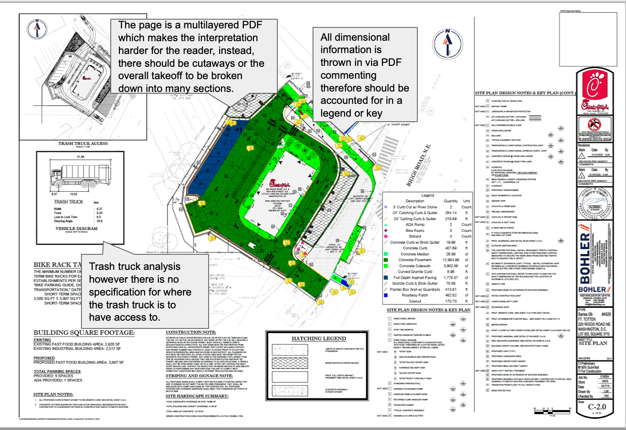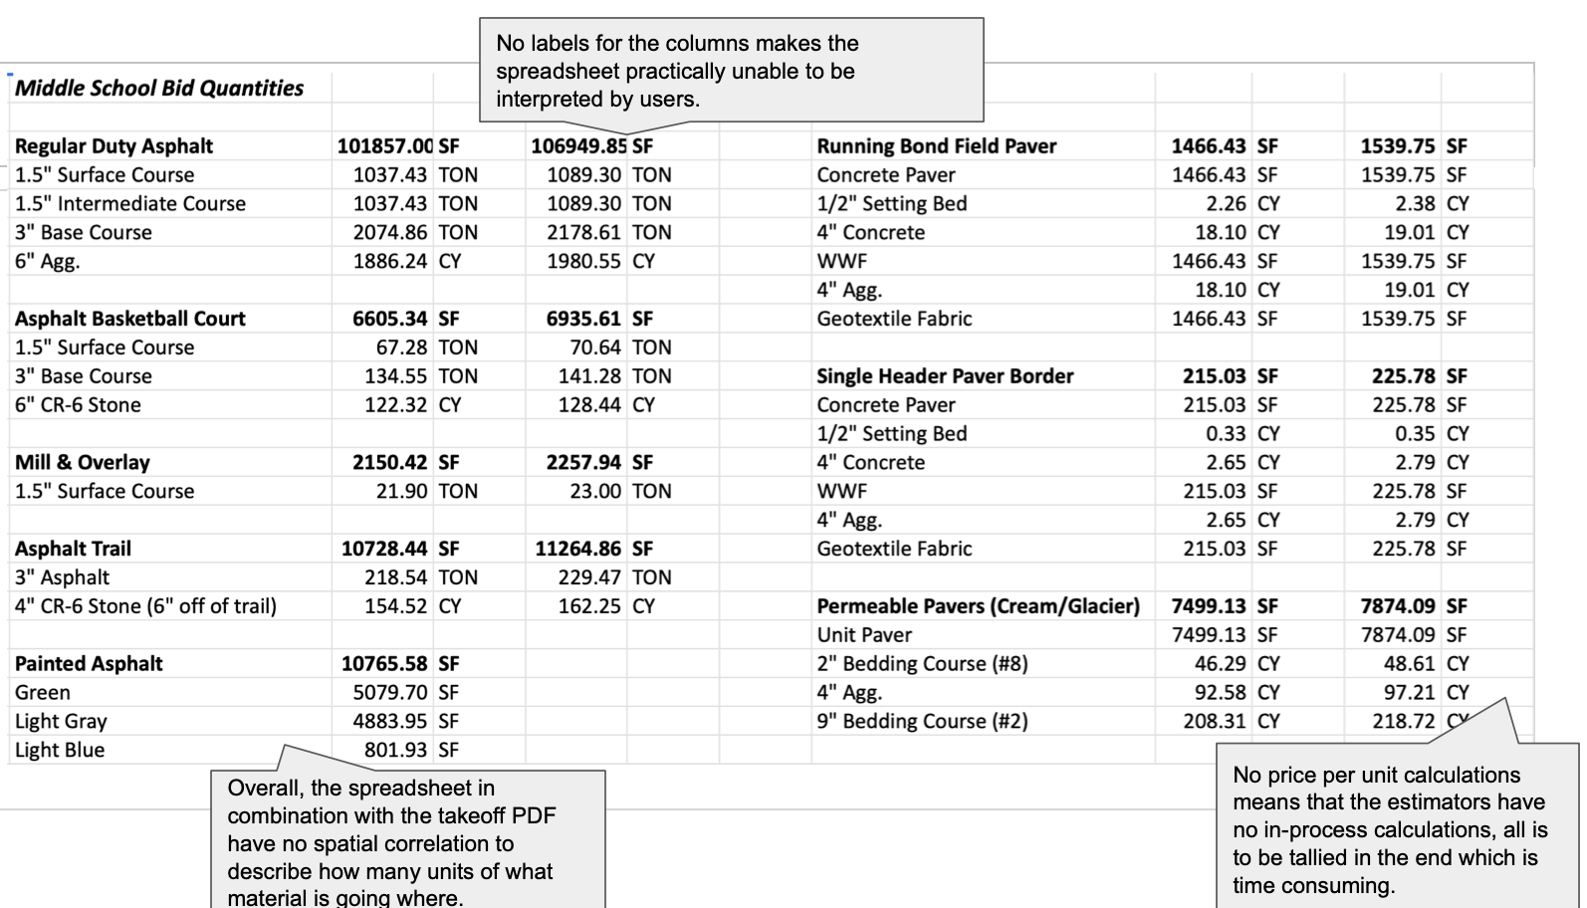

## **Section 2: Use Case Analysis**

This section contains the three main use cases that our team was able to identify from our interview with the site contact. These use cases will be presented in the fully-dressed format. Included elements of the use cases will be name, priority, ID, actors, description, trigger, preconditions, normal course, exceptions, postconditions, inputs, source, outputs, and destination.

|  |  |  |
| --- | --- | --- |
| **Use Case Name:** Create Project Takeoffs | | **Priority:** High |
| **Actor:** Estimators, Bluebeam | | |
| **Description:** | Estimators use Bluebeam, after mapping out project location, to identify the components and raw materials associated needed for the potential project so that costs can be calculated which makes up a “takeoff”. The purpose of the Bluebeam software is to allow the teams to be on the same page through the design portion of the procedure, it assists moving the project forward during the construction and lastly, it reserves the essential project data through completion and going forward and beyond with the process. | |
| **Trigger:** | Estimators begin the bid process for a potential project | |
| **Type:** | ☑️ External | ⬜ Temporal | |
| **Preconditions:** | 1. Fort Myer has been invited to launch a project bid 2. The project requirements are analyzed 3. The location has been mapped | |
| **Normal Course:** | 1.0 Identify Materials Required   1. Estimators import the civil drawing to Bluebeam where it becomes a Takeoff   Input: Civil drawing being moved to Bluebeam  Output: Creation of takeoff   1. Items and their sizes are noted within the takeoff   Input: Civil drawing  Output: Takeoff with notations   1. The system lists the potential components required for the project   Input: Takeoff/Civil Drawing  Output: The system lists the potential components   1. The components are then itemized with raw materials needed   Input: Data, diagrams, schematics, etc.  Output: Raw materials needed | |
| **Alt Course or Exceptions** | Exception:  E1: Fort Myer lacks the resources needed to complete potential project   1. Project bid offer is declined   E2: Estimator incorrectly measures and draws sizes needed for takeoff   1. Area must be remapped and re-measured 2. Quantities and sizes of components must be recalculated 3. Updated information is passed to other estimators for review | |
| **Postconditions:** | 1. Takeoff must be reviewed and approved by Lead estimator 2. Estimators are handed takeoffs to continue calculating raw materials costs | |

|  |  |  |  |
| --- | --- | --- | --- |
| **Summary Inputs** | **Source** | **Outputs** | **Destination** |
| The requirements for the drawing  Civil drawing being moved to Bluebeam  Civil drawing  Takeoff/Civil Drawing  Data, diagrams, schematics, etc. | Estimators | Civil drawing  Creation of takeoff  Takeoff with notations  The system lists the potential components  Raw materials needed |  |

|  |  |  |
| --- | --- | --- |
| **Use Case Name:** Calculate Design Costs | | **Priority:** High |
| **Actor:** Estimators, CLI (Construction Link Incorporated) | | |
| **Description:** | Completed components list will then be fed into CLI which indicates itemized raw materials needed for a component. Using this information, estimators use excel to calculate a total cost of raw materials. | |
| **Trigger:** | The components list has been completed | |
| **Type:** | ☑️ External | ⬜ Temporal | |
| **Preconditions:** | 1. Takeoff has been completed 2. Overall project design is completed | |
| **Normal Course:** | Request subcontractor to bid on job  1.0 Identify and input the materials required  1. Input the material needed manually  2. Input the quantities needed manually  Input: Material and quantity needed  Output: Subcontractor bid offer  2.0 System records field tracking, billing   1. After inputting all the materials and quantities, it gives the total estimation   Input: Records tracking and billing  Output: Total cost estimates | |
| **Alt Course or Exceptions** | Exceptions:  E1: Estimators forget to include a component   1. The document is sent back to estimators for review and correction   E2: Estimators did not input the correct quantity of materials needed   1. The program miscalculates the bidding or total estimation 2. Estimators can re-check the estimation to correct the quantity   3a. The program asks to manually enter the quantities of materials again.  3b. The program re-calculates the estimation.  4a. The program gives new bidding or estimation. | |
| **Postconditions:** | 1. Overall material cost is calculated 2. Gives total estimation of profit and overhead | |

|  |  |  |  |
| --- | --- | --- | --- |
| **Summary Inputs** | **Source** | **Outputs** | **Destination** |
| 1. Material and quantity needed 2. Records tracking and billing | 1. Clients | 1. Subcontractor bid offer 2. Total cost estimates | 1. Legal team 2. Estimators 3. Ppl who deliver/submit the finished product |

|  |  |  |
| --- | --- | --- |
| **Use Case Name:** Bidding Process Submission (Submit Final Bids) | | **Priority:** High |
| **Actor:** Estimators, applications | | |
| **Description:** | Once the required bidding documents have been completed and compiled, Fort Myer must approve and submit bids to clients before the specified deadline. | |
| **Trigger:** | Bids are fulfilled by estimators | |
| **Type:** | ⬜ External | ☑️ Temporal | |
| **Preconditions:** | 1. Bids are given to estimators 2. Bids are calculated and finalized | |
| **Normal Course:** | 1.0 Full bid package is submitted to the client   1. Client requires a manual submission    1. Estimators travel to the destination of the client’s office    2. A hardcopy is delivered by the deadline   Input: Client requires submission  Output: Bid package delivered   1. Client require an electronic submission    1. The bid is reviewed and approved   Input: Client requires the electronic submission  Output: The bid is reviewed and approved   1. The company begins the project   Input: The bid is reviewed and approved  Output: Company begins the project | |
| **Alt Course or Exceptions** | Exceptions:  E1: Estimators fail to deliver the documents before the deadline   1. Project cannot begin | |
| **Postconditions:** | 1. Bids must be submitted 2. Bids must be approved | |

|  |  |  |  |
| --- | --- | --- | --- |
| **Summary Inputs** | **Source** | **Outputs** | **Destination** |
| 1. Client requires submission 2. Client requires the electronic submission 3. The bid is reviewed and approved | 1. Estimators 2. Bluebeam 3. CLI | 1. Bid package delivered 2. The bid is reviewed and approved 3. Company begins the project | 1. Private clients 2. Commercial clients 3. Governmental clients |

## **Appendix**

|  |  |
| --- | --- |
| **Title:** | Interview #1 |
| **Dates:** | February 23, 2021 |
| **Duration:** | 31:55 |
| **Interview medium:** | WebEx |
| **Site Contact:** | Tiago Torres |
| **Organization:** | Fort Myer Construction |
| *(No one else will interview from the company)*  *(Tiago is available to answer any other questions from the team)* | |

Functional requirements of as-is system

|  |  |
| --- | --- |
| Process-oriented | Information-oriented |
| * Pricing must be done manually in CLI application * Excel is used for calculating by formulas * Bid submission is done half manually and half digitally/electronically * Planswift application only exports by pdf * CLI is display only and cannot work simultaneously * Excel file goes into a CLI * Takeoff, ask for prices, modify numbers, do the private work | * Has an email filter that forwards bid invitations to another email * Uses many different programs that are difficult to learn and use |

Functional requirements of to-be system

|  |  |
| --- | --- |
| Process-oriented | Information-oriented |
| * Detect and filter bids * Reduce time from two weeks to one * Price accurately to bid on as many jobs as possible * Be able to support simultaneous collaboration * Let users mount bids quickly, accurately, and efficiently | * Have backups for files and be available even when servers are down * Bid submission should be fully electronic instead of manual * Have an easy to use interface * Have all bid invitations in one place (centralized and consolidated) |

1. **What's your role?**
   1. Estimating Assistant
   2. Started as an intern
2. **What does your company do?**
   1. Contractor – set up site work (mostly asphalt and concrete)
   2. Own the only two asphalt plants in DC
   3. President and Exec Vice President give permission to bid on public projects
   4. Estimators have jurisdiction to bid on private projects
3. **What is the significance of your job?**
   1. Estimators price up a job for the company to bid on
   2. Bidding is how all the jobs are received
   3. Bid invitations come in through email
      1. 50+ a day
      2. Unique company email gets all the bids then forwards to estimators
      3. Emails get choked up with amendments
      4. Easy to miss messages
4. **What are your day-to-day responsibilities?**
   1. Mostly works on private and commercial bids
   2. Will assist on public bids
   3. First step is to do take-offs (quantities, material, labor)
      1. Public bids the quantities are already given to you by government
   4. Prices you will get from other companies (can’t do all the work yourself)
      1. Fort Myer does all concrete and asphalt, but striping, landscaping etc. not us
      2. That work is subcontracted
      3. For both public and private you have to request the subcontractor to bid on your job.
      4. Fort Meyer is the Prime contractor
      5. Subcontractors will provide prices for other companies including the competitors
      6. You will choose the cheapest one (unless they are unreliable or unsafe)
5. **Who do you report to?**
   1. COO or CFO (3rd in the company)
   2. Head of all estimating
   3. 63 years old
   4. At the company since the 1980s
   5. Has final ultimate say on every public job
   6. Uses a program called CLI (estimating software)
      1. He prefers its simplicity over the new programs they have
   7. Estimating is the most important department
      1. They are the ones who make the company money and find work
6. **How much user interface is needed to use the systems currently in place?**
   1. Currently work almost entirely on the computer
   2. Uses 3 or 4 programs through his work computer
7. **How steep is the learning curve to learn how to use the systems in your company?**
   1. Not that steep
   2. Takeoffs on “BlueBeam” and “Excel” are pretty easy
      1. Week or two to pick up the general process
   3. Vista will deal with the bidding backend (very complicated)
      1. Sets up the job
      2. Puts in all the items (labor)
      3. Accounting (payroll)
      4. Estimator mounts the job here
   4. 2 programs that aren’t used by estimators
      1. Earthcore (takeoffs specifically for earth works)
         1. 1 in 5 jobs would need Earthcore
         2. Common in public jobs
   5. CLI (Construction Link Incorporated)
      1. does all the estimating
      2. put in all the prices and quantities and gives a total
      3. Automatically includes profit and overhead
      4. Quite simple to master the program
      5. DOES NOT replace Excel
      6. Manually input the material and the quantity
         1. to get the quantity you need
   6. Excel
      1. used for materials in your takeoffs
      2. uses formulas to calculate the quantities required for each job
         1. square footage of asphalt needed = X amount of tons of asphalt
         2. Truck loads need to be rounded up (can’t do half load or empty loads)
8. **What processes do the designated systems streamline?**
   1. Takeoffs (take roughly 4 hours to a few days depending on job size)
      1. Get rid of Excel as the middleman software
      2. Take the square footage of asphalt and in one step convert it and import it into CLI
      3. Civil drawings (which are used to create takeoffs) reference other details needed for the completion of the work
         1. Most sidewalks in DC are 4 inches concrete, wire mesh, and 4 inches of gravel (but not always the case)
         2. Drawings will have the details about different types of curbs that could change the amount of concrete required
9. **Is there any system that you feel is insufficient for your work needs?**
   1. CLI does pretty good once you have all info
      1. Rate table for prices of quantity
      2. Knows how much we pay workers
      3. DOES NOT know how much we pay subcontractors
      4. Have to wait until they give you prices and then manually put them in
      5. Can’t look up subcontractor prices in a library

|  |  |
| --- | --- |
| **Title:** | Interview #2 |
| **Dates:** | March 4, 2021 |
| **Duration:** | 27:38 |
| **Interview medium:** | WebEx |
| **Site Contact:** | Tiago Torres |
| **Organization:** | Fort Myer Construction |

1. **What systems does your job require?**
   1. Bluebeam
      1. You can see everyone else’s work and modify it
      2. You can see the author of the takeoff
   2. CLI (Construction Link Incorporated)
      1. Only allows one user to edit at a time (half-duplex)
   3. Excel
      1. Errors here could cause an inaccurate bid process and lose jobs
   4. Vista (project management)
      1. used to use maxwell
      2. has bugs where sometimes you can’t import costs and they need to be calculated manually (takes extra 3 hours)
   5. Plan Swift
      1. Once you start work on a takeoff, no one else can work on that file
      2. Once project file is saved it’s flattened (pdf)
2. **Is there any way to make your system more efficient for you?**
   1. The more jobs you bid, the more jobs you will win
   2. Healthy company wins 2-10% of the jobs they bid
   3. Not enough time to price out estimates
   4. Department of estimating does about one estimate per day
   5. Takes 2-3 weeks to do public jobs (subcontractors need time to get back to you)
   6. Private bids are quicker because you don’t need as many subcontractors
      1. less expensive
      2. less things to worry about
      3. quickly mount a bid in a few days
      4. Project bid start to finish in less than 4 days
   7. Remove Excel from the equation saves an hour on a project
   8. Speed up takeoffs proportionally to the size of the job
   9. Some materials are unique to a project and need to be manually written in
   10. Multiple people working on the same takeoff at once (bluebeam & CLI)
       1. many phone calls for people to hop off CLI file so others can edit it
   11. Auto check Excel spreadsheets resolve with CLI
3. **Is all your systems electronic, if not would you like them to be?**
   1. Bid submission (partially electronic)
      1. Better if it was fully electronic
      2. Manual turn in of full bid package precovid
         1. Drive/fly out to office of client by deadline
         2. One job in Colorado for a client (lost the job)
   2. Electronic bid submission saves 2 hours
   3. 2 in 5 are still manual turn in postcovid
   4. Up to the client whether it’s manual or electronic
   5. Reading out bid results requires everyone to be present, no errors, everything signed and authorized. Read out over video conferences or in person.
4. **Do the systems in place streamline any processes or do they seem to complicate them?**
   1. IT Department
      1. Maintain servers
      2. Server downtime prevents access to files during certain periods
      3. Project files are over a Gigabyte
      4. Due day downtime is absolutely not tolerable
5. **Will the system need to be highly reliable (have less than 5% downtime)**
   1. Backups are good for now
   2. Less than 5% downtime tolerated
6. **How soon would you need to use it?**
   1. ASAP
7. **Would this be a long-term or short-term solution?**
   1. Long-term permanent solution
   2. Before 2005 takeoffs were done totally by hand
8. **What are the user requirements**
   1. Who would be the users?
      1. Takeoffs and Bids = Estimators
      2. Contract Documents = Legal Team
         1. Estimator has to make sure the contract matches to the agreed prices
   2. Are they technologically adept?
      1. Yes, everyone is
9. **Would this be implemented as part of a phased rollout?**
   1. ~~Throw away?~~
   2. ~~Evolutionary?~~
   3. **Incremental?**
      1. Slower rollout
      2. No mistakes and thorough training
10. **What is the metric for project completion in your role?**
    1. Private Bid Process
       1. Takeoffs 🡪 Prices 🡪 Mount Bid (CLI) 🡪 Tweak Prices (Subcontractors) 🡪 Bid
11. **What business processes are in place and could use refinement or are perfectly fine the way they are?**
    1. Shortening the bidding process would allow higher work volume with the same amount of employees and overhead
12. **How is quality assured in your current role?**
    1. How fast an estimator can mount the bid
    2. How close the estimator’s price is to our competitors
       1. Public project prices are made public afterwards
       2. If you’re not close to the others, you’re not doing a good job
       3. Way too cheap = leaving money on the table
       4. Gap between first and second place is free money
       5. Within 1-2% of second place price
    3. Estimator ensures spreadsheets match CLI

# **4. Process Modeling Documentation**

## **Section 1: Process Modeling**

### **Section 1.1: Context Diagram**

This is the top-level data flow diagram in every business model. This diagram shows the entire information system as a single business process. The entities, dataflows, inputs, outputs, sources, and destinations are drawn from the information contained in our interview notes, use cases, and requirements definitions. Later in this document, there will be an extrapolation of this diagram to include greater detail.

### **Section 1.2: Level 0 Data Flow Diagram**

This diagram shows all the major processes at the first level of numbering inside the Bidding Management System. Included are the data stores, external entities, and data flows between each entity. The five processes shown, the four data stores, and numerous data flows shown in the level 0 diagram are contained within process 0 of the Context Diagram displayed previously.

### **Section 1.3: Level 1 Data Flow Diagrams**

These data flow diagrams show the children of each parent process included in the Level 0 DFD. Because these Level 1 diagrams are decomposed from the previous Level 0 diagram, they will show some data flows that have not yet been seen inside the Bidding Management System.

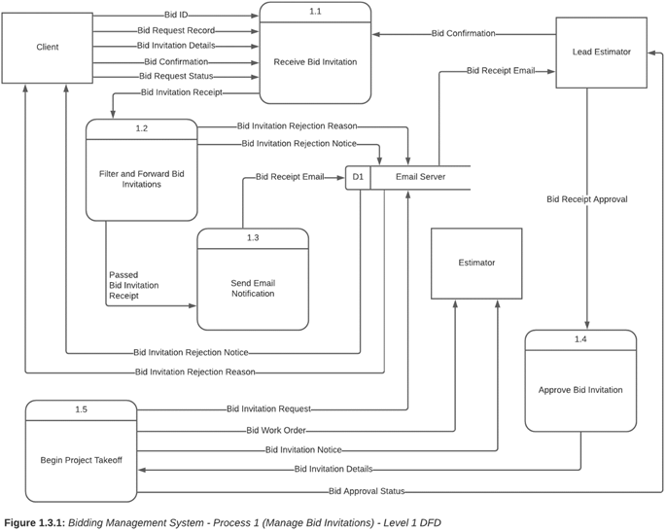

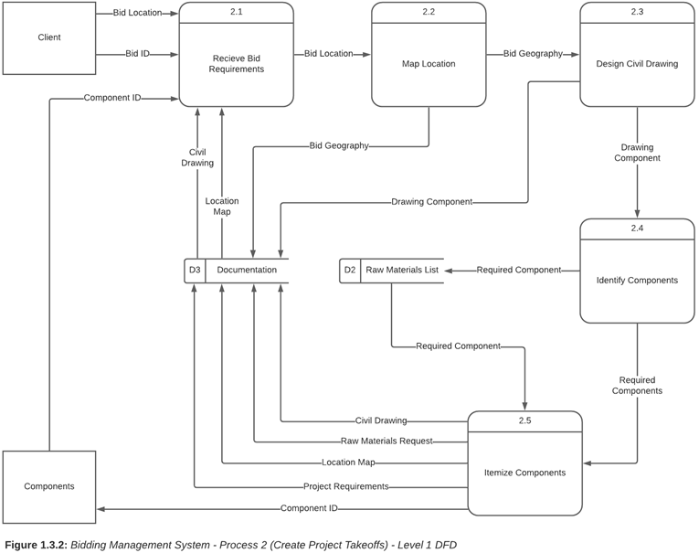

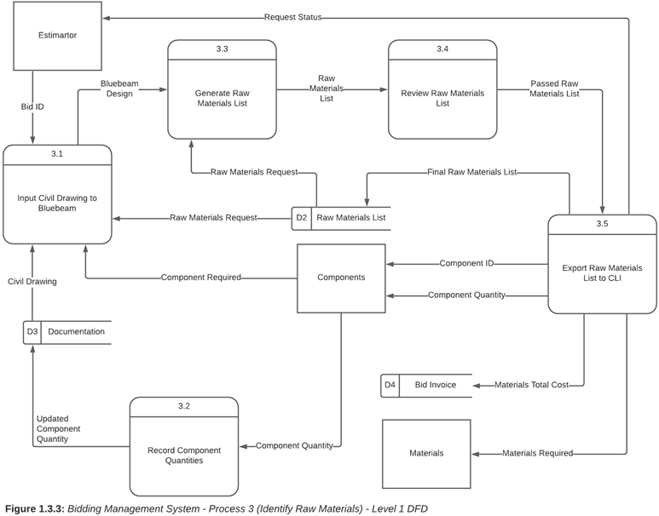

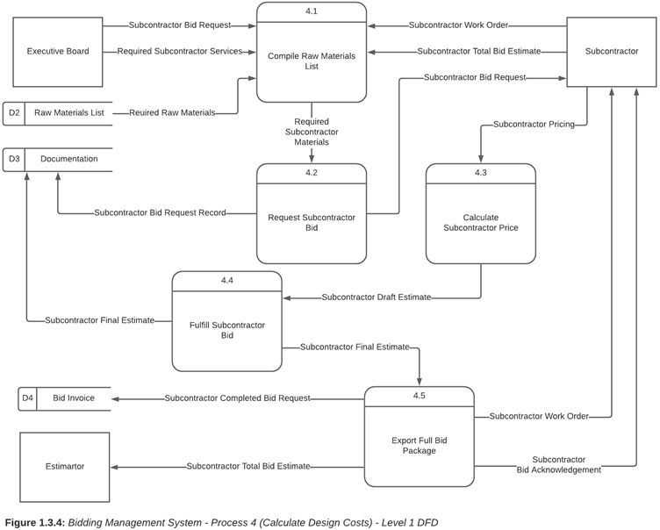

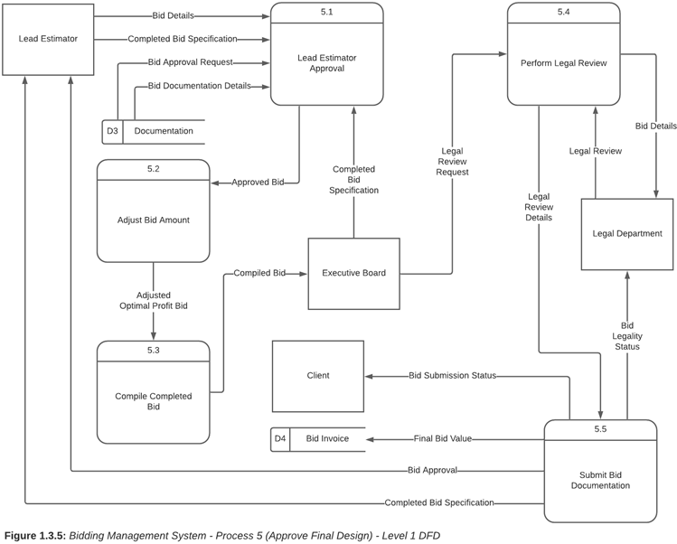

## **Section 2: Data Dictionary Definitions**

This Data Dictionary for Fort Myer’s Bidding Management System contains the name, type, description, what each element contains, and constraints and/or data types of five elements within the Level 0 DFD presented earlier.

**Name:** Bid Invitation Notice

**Type:** Data Flow

**Description:** Clients send bid invitations via email to Fort Myer. The email server automatically forwards invitations to estimators who determine the feasibility of fulfilling requirements. The notification is an event triggered after the bid is approved.

**Synonyms:** Client Email Notice

**What it contains:** Bid_ID, Bid_Name Bid_Date, Bid_Status

**Constraints/data type:** Bid_Status varchar(20)

**Name:** Estimators

**Type:** Entity

**Description:** Contains information about estimators who accept and attempt to win bids. Bid values determine the amount of profit the company will receive for the job they win. Estimators develop a list of components composed of the cost and quantity of raw materials based on the bid’s requirements. Project takeoffs are designed by estimators from the components list necessary for a full bid package.

**Synonyms:** Bid Appraisers

**What it contains:** Est_ID, Est_firstname, Est_lastname, Bid_ID

**Constraints/data type:** Est_ID must be a unique primary key, Bid_ID must be a foreign key

**Name:** Clients

**Type:** Entity

**Description:** Contains all client information. Clients create construction plans in collaboration with an external entity designer to contract out those plans to companies like Fort Myer. They then receive the final bids from contractors and choose the most cost effective bid and prepare the contracts for completion of the project.

**Synonyms:** Customers

**What it contains:** Client_ID, Client_Fname, Client_Lname, Client_Street, Client_City, Client_State, Client_Zip

**Constraints/data type:** Client_ID must be a unique primary key

**Name:** Suppliers

**Type:** Entity

**Description:** Contains all information for suppliers to provide requested raw materials in order to fulfill necessary requirements.

**Synonyms:** Vendor, merchant, seller

**What it contains:** Supplier_ID, Item_ID, Item_Name, Item_Quantity, Date_Added

**Constraints/data type:** Supplier_ID must be unique

**Name:** Email Server

**Type:** Data Store

**Description:** All bid offer invitations are stored here. Bid invitations are sent by clients via email and forwarded to the email server. Lead estimators have access to the company’s email server in order to verify and approve the invitation details. After approval, lead estimators distribute the details of the bid invitation to company estimators.

**Synonyms:** Bid invitations

**What it contains:** Bid_ID, Client_ID, Bid_Name, Bid_Date_Created, Bid_Deadline, Bid_Status

**Constraints/data type:** Form is an email platform

# **5. Data Modeling Document**

## **Section 1: Developing a Data Model (ERD)**

This section includes an Entity Relationship Diagram (ERD) which is a structural diagram used in database design to visualize the information that is created, stored, and used by a business system. The following ER diagram illustrates the relationship between various entities in the bidding process of Fort Myer. Entities depicted in this model include external entities, data stores, as well as other processes taken from the Level 0 diagram in the previous deliverable. Additionally, each entity created has a relationship with those around it is best exemplified by its cardinality. For instance, The Client and Bid entity have a mandatory-one to optional-many relationship where clients may or may not submit one or many bids however, a bid must be submitted by one client. Each entity contains attributes to further signify necessary data types (e.g., The Supplier entity contains attributes named ID number, name, address, etc.).

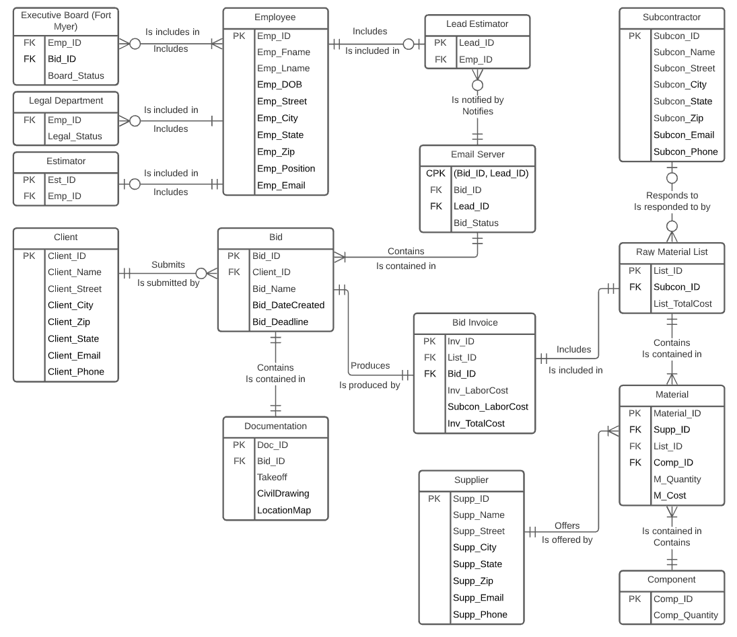

## **Section 2: Developing a Alternative Matrix**

When deciding how to approach Fort Myer’s bidding system redevelopment we analyzed and evaluated three distinct approaches. We could build a new system from the ground-up, introduce pre-packaged software, or modify/re-work the existing system. If we were to build a new system we would be able to fit most if not all of Fort Myer’s needs into the new system. The problem with this solution is that there is a large time cost as well as a large monetary cost. Another approach we considered was buying and adapting pre-packaged software (such as office 365). This would help solve some issues such as not being able to have collaborative abilities in some aspects of the bidding process, as well as the centralization of some of the tools required. This approach allows us to implement the new system relatively quickly but is not designed for the client’s needs directly. The final alternative we considered was reworking/modifying the existing system. This would be more customized but limited in functionality due to the complexity of the existing bidding system. There is not much we would be able to change without overhauling the entire system. The benefits of this approach is that it is quick to implement and has the lowest costs associated with it. It also is easy to learn which helps ease the transition. After weighing the requirements for our client, we have come to a conclusion that the custom-built system would provide the most benefits and fulfill Fort Myer’s biggest concerns.

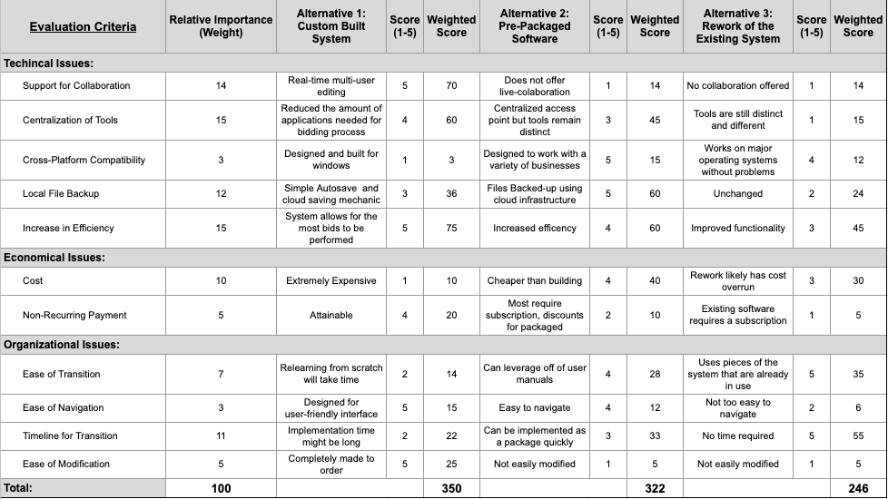

## **Section 3: Alternative Matrix 2 and Hardware/Software Specification**

This section includes our team’s non-functional requirements matrix (Alternative Matrix 2). In which we display each of the network architecture alternatives and check off how each one satisfies our requirements or not. Following Alternative Matrix 2 we discuss briefly how some of the architectures are a good fit for some of the non-functional requirements. Included after the discussion is our final choice of network architecture and the rationale behind it. Finally, the last element included in this section is the Software/Hardware Specification in which our team provides the granular configuration of the chosen architecture.

### **Section 3.1: Alternative Matrix 2 (Non-Functional Requirements)**

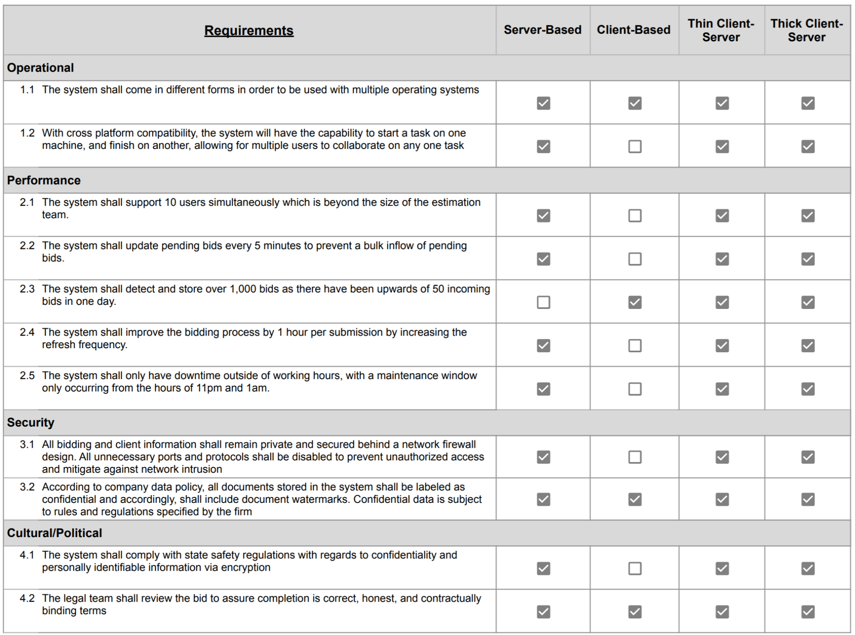

### **Section 3.2: Network Architecture Selection**

Based on the project conducted, the best suitable architecture is the Thin Client-Server. This is highly recommended for our company because most of the necessities are being met in Thin Client compared to Server-Based, Client-Based, and Thick Client-Server. The Thin Client-Server is lightweight and since the bids are required for the system to perform well, then our architecture should be network based rather than Thick Client. Thick clients are meant for local work and Thin Client relies on the network. In our case, since we are doing bids and are communicating between systems internal and external, it would be superior to our system to be a Thin Client. The textbook *Systems Analysis and Design* incorporates that Thin Client is common and easy to support and maintain. In other words, it is widely popular in the industry.

One can clearly see that this alternative satisfies every last non-functional requirement specified in Fort Myer’s requirements definition document. However, one can also see that the Thick Client-Server option was an equally excellent choice per the requirements. So our team had to dig deeper into the particulars of what each of the two architectures provides in regards to capability and cost/benefit outlook. Cross referencing this with the unique requirements of Fort Myer lead us to our conclusion. Our team was looking for the most cost effective solution. Thick Client-Server architecture possesses higher hardware requirements, more cabling/bussing, and relies solely on the hardware resources of the server. All this leads to much higher implementation cost. Thick Client-Server architecture also requires terminal installation with standalone operating system and software configurations. This is not only more expensive, but much more inefficient to update and maintain. Thin Client-Server provides much better patching, data migration, and troubleshooting administration. For these reasons and more, the widely popular Thin Client-Server architecture is the logical choice.

### **Section 3.3: Hardware/Software Specification**

|  |  |  |  |  |
| --- | --- | --- | --- | --- |
|  | **Standard Client** | **Standard Web Server** | **Standard Application Server** | **Standard Database Server** |
|  | | | | |
| **Operating System** | Windows 10 Pro | Linux/Unix | Linux/Unix | Linux/Unix |
| **Special Software** | Bluebeam  Adobe Acrobat Reader  Microsoft Office 365  PulseSecure VPN Client | NGINX | Java | MySQL |
| **Hardware** | 1TB HDD  Intel I5-4600K(4 cores)  8GB RAM  22-inch LED Monitor | 8TB HDD  Intel Xeon D-1649N Processor(8 cores)  32 GB RAM | 8TB HDD  Intel Xeon D-1649N Processor(8 cores)  32 GB RAM | 32TB HDD  Intel Xeon D-1649N Processor(8 cores)  32 GB RAM |
| **Network** | Wifi  Broadband | Dual 100 Mbps Ethernet | Dual 100 Mbps Ethernet | Dual 100 Mbps Ethernet |
| **Cost (Technical Training, Maintenance, Licensing, etc.)** | $700-$1,000/Workstation | $1,000-$5,000 | $4,000-$10,000 | $4,000-$10,000 |

|  |  |  |
| --- | --- | --- |
| **Hardware** | **Quantity** | **Cost** |
| **Printers/Scanners** | 5 | $10,000 |
| **Keyboard** | 100 | $3,000 |
| **Mouse** | 100 | $1,000 |
| **Monitor** | 50 | $7,000 |
| **Desktop** | 50 | $30,000 |
| **Disk Drives** | 30 | $4,000 |
| **Web Server** | 4 | $10,000 |
| **Ethernet Cables** | 300 | $5,000 |
| **Application Server** | 4 | $10,000 |
| **Database Server** | 4 | $10,000 |
| **Backup Disk Drives** | 15 | $2,000 |
| **Total** | **662** | **$92,000** |

# **6. User Interface, Physical Process and Data Models**

## **Section 1: User Interface Design**

User interface standards are basic design elements that are common across the entire system such as screens, forms, and reports within the system. When designing the user interface, consistency increases user efficiency and usability by allowing users to predict what will happen in the system and subsequently allows them to interact with the rest. To increase the consistency of the user interface, design principles such as layout, content awareness, aesthetics, usage level, consistency, and minimal user effort are all taken into account.

Creating a layout consistent across all systems includes the middle area for information input and output, the bottom area for status information and markup history, and the top area and sides for navigation and resources respectively. Content awareness refers to the user being aware of where they are in the system and what information is displayed. Creating the system with some familiarity with the current system in place while being mindful of increasing the user’s experience and ease of navigating when designing the new user interface are best implemented by incorporating titles within interfaces, labels for user input and output, and version numbers of the application as a footer, the system allows the user to familiarize themselves within the system.The aesthetics for this system is consistent with Microsoft Windows which is the primary operating system within Fort Myer. It is functional and inviting to the users by adopting a minimalistic approach for an aesthetically pleasing look without losing important information. A uniform and minimal color scheme, icon pattern library, and color-coding for denoting status information is coherent and harmonious with Microsoft Fluent Design. Additionally, the text and typography of the new interface are important aspects regarding the aesthetics. Therefore, these aesthetics are in a legible and easy to read font with minimal colors balancing both functionality and aesthetics. The common theme for the new user interface includes a minimal yet easily recognizable and practical design remaining consistent with the color palette, theme, and shapes implemented.

The usage level design principle focuses on producing a system that accommodates both frequent and infrequent users. Through implementing basic user interface functions and existing conventions, the balance between ease of use and ease of learning will be taken into consideration for the application. Due to the high level of application knowledge necessary for understanding and using the previous system, it is critical that existing conventions are taken into consideration for the designing and planning of the new interface. The method of using conventions that are already universally understood is the simplest way of balancing functionality and usability for new and experienced users alike. Combining Excel and CLI into a singular platform allows estimators to perform all required functions on a single application and complete tasks more efficiently and effectively. Consistency also allows users to predict what will happen before performing a function. The system will be predictable and expandable to the nth degree by keeping symbols, icons, terminology, and commands uniform. Finally, to increase the consistency of the user interface across the entire system, the minimal user effort design principle is taken into consideration by following the three-clicks rule. This reduces the amount of effort required by the user to accomplish tasks and it is crucial for creating a seamless user experience.

## **Section 2: Interface Design Prototypes**

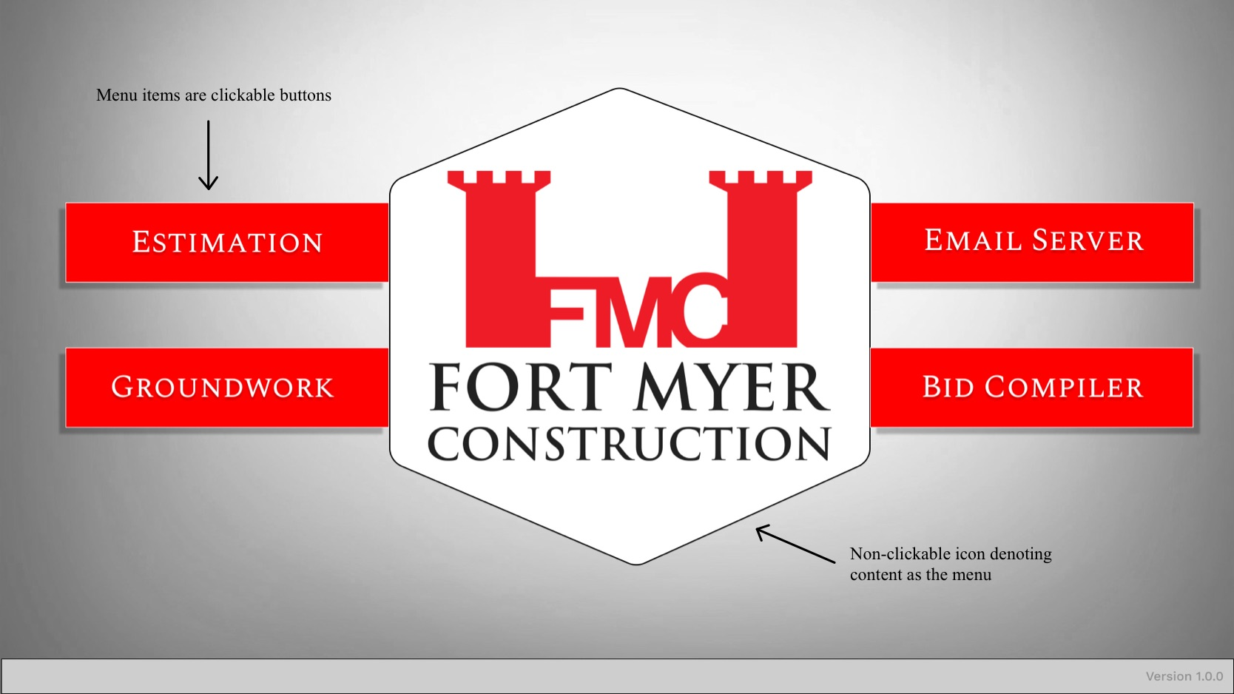

*Figure 1: Menu Screen*

This screen visualizes the launch page where users can select which app or software they want to open. The 4 options are buttons that surround our client’s logo and fit their color scheme.

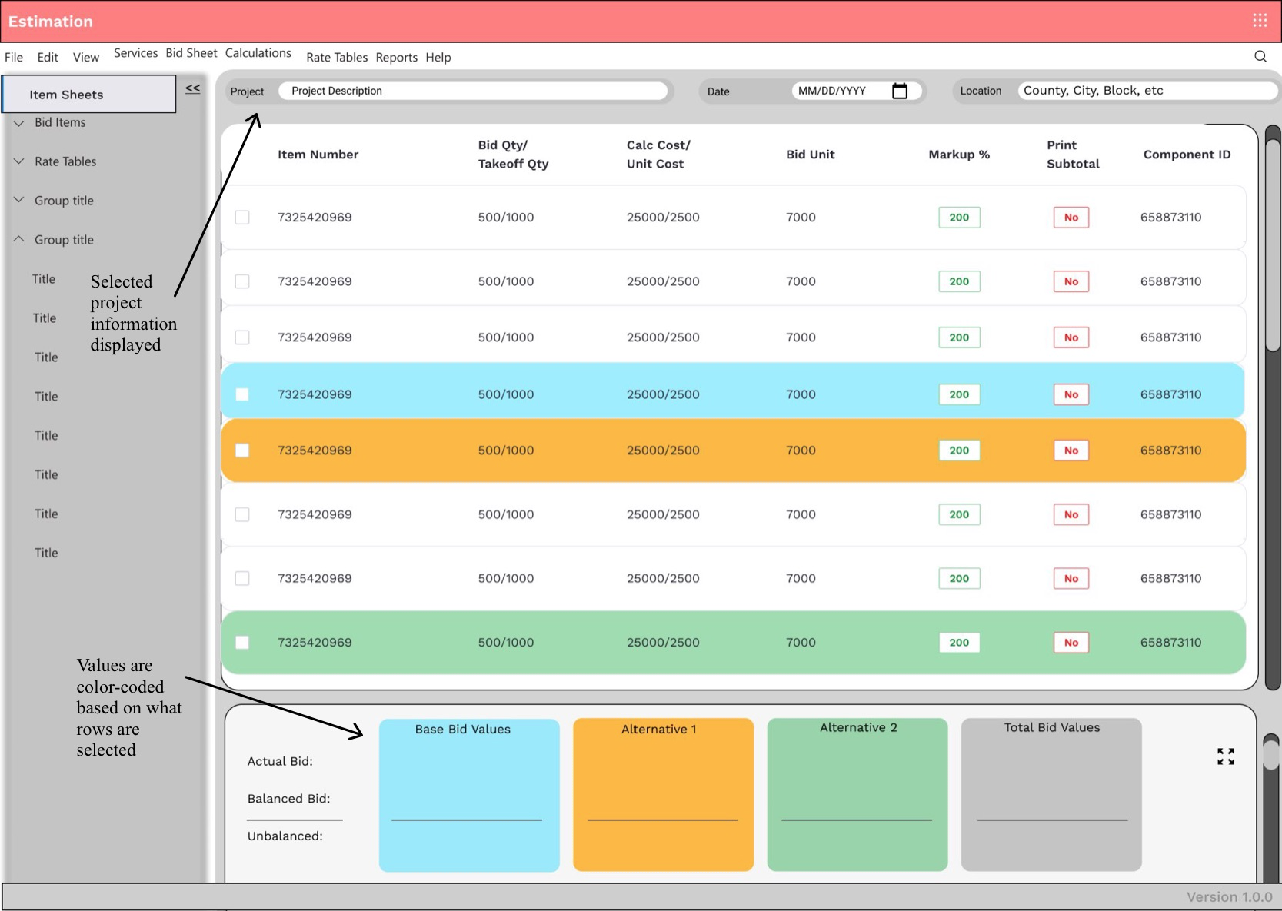

*Figure 1.1: Estimation*

The screen above visualizes a spreadsheet for the selected project and it highlights key values. It also allows users to manipulate the data and calculate necessary values in a separate area.

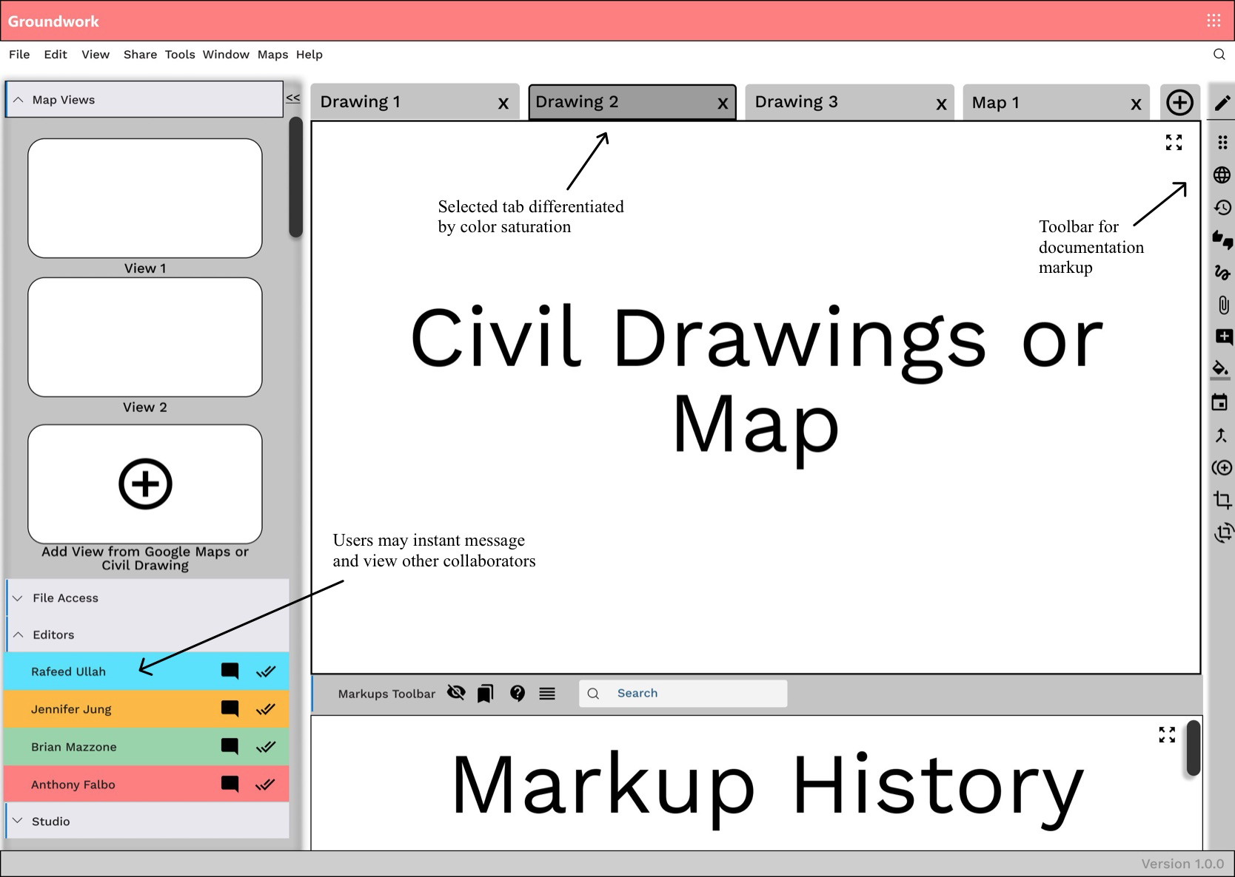

*Figure 1.2 - Groundwork*

This screen allows users to create and edit civil drawings as well as reference maps and views. It features a highly detailed markup history section, as well as a collapsible multi-use left sidebar with features such as file access for reference or access to co-collaborator reference. The right toolbar features an extensive multitool editing assistant for use when creating the civil drawings.

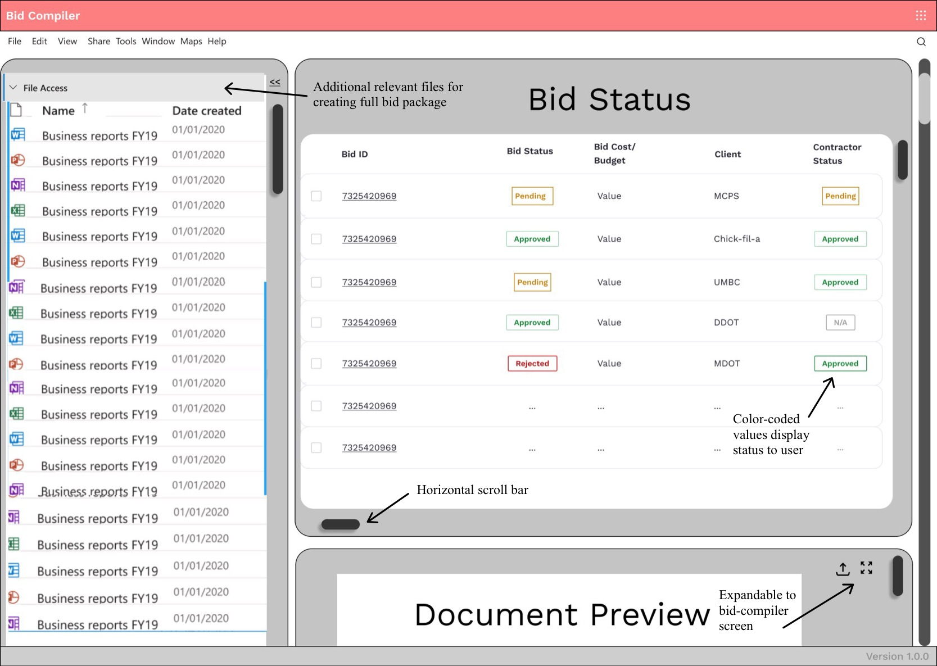

*Figure 1.3 - Bid Compiler Menu*

The Bid Compiler Menu above depicts all bid packages consolidated to one platform. Users are able to view the status of numerous bids as well as preview other documents included in the bid before sending it to the client. Additionally, bids can be accessed through this screen by clicking the desired bid ID which directs the user to Figure 1.4 below.

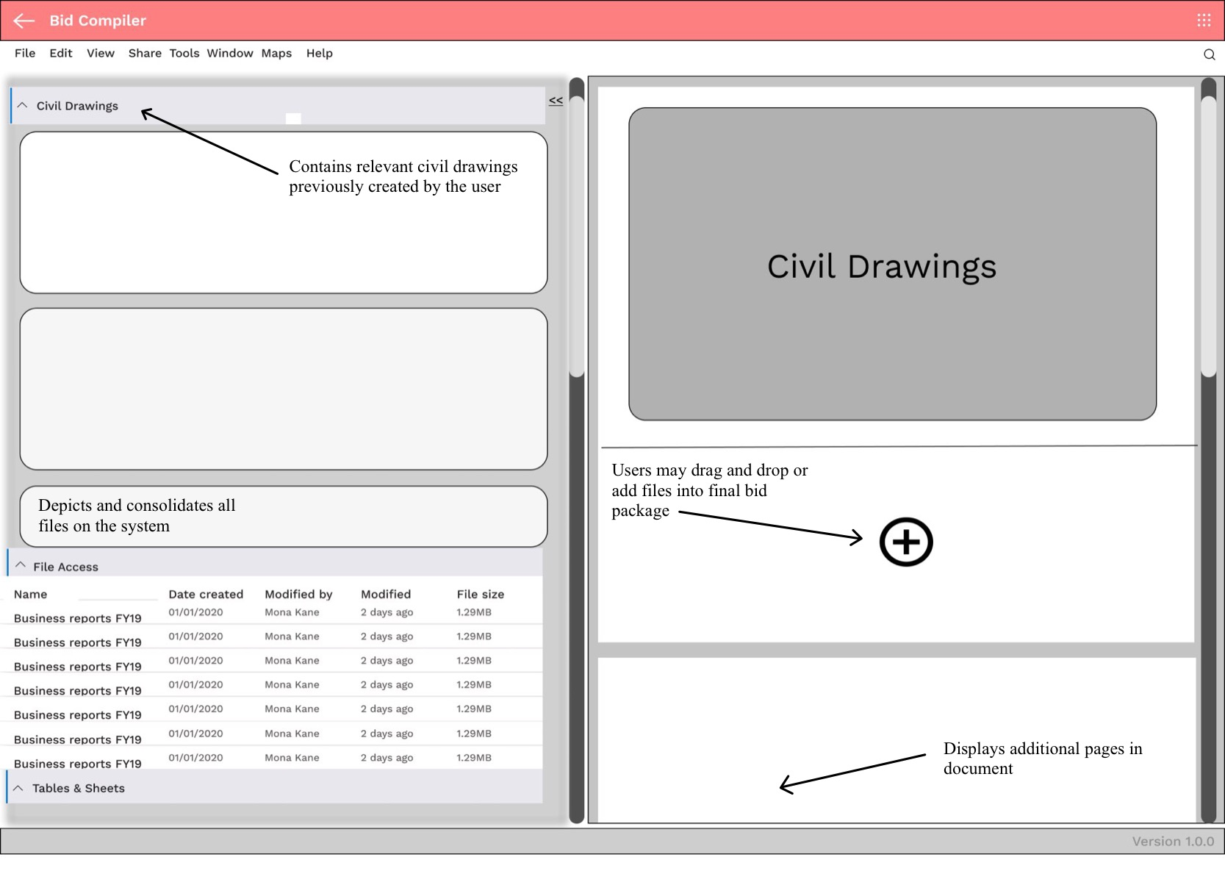

*Figure 1.5 - Bid Compiler*

The screen is a part of the Bid Compiler application that allows users to drag and drop elements into the final bid document. This gives users simple access to all relevant documentation and simple editing tools.

## **Section 3: Logical Level 0 DFD Model**

The logical model of an entity relationship diagram depicts the “business view” of the data, but omits implementation details. So, the physical data model depicts implementation details, “system view” and shows “how” the final system works. The transition from the logical to physical data model has certain steps : Adding implementation references, drawing a human-machine boundary, adding system related data stores, data flows and processes, updating data elements in data flows and updating metadata in CASE repository. In the first step, the implementation details of data stores such as “HTML” is added to Bid ID, Bid Request Record, etc. In the second step, a human-machine boundary is drawn to differentiate human action from automated processes. For example, in this diagram Process 5.0 is separated from the boundary since it is a manual process whereas there is a boundary to the processes 1.0, 2.0, 3.0, 4.0 as they are machine processes. In the next step, any additional processes, stores, or flows are added. The elements in the data flows are updated in the next step.

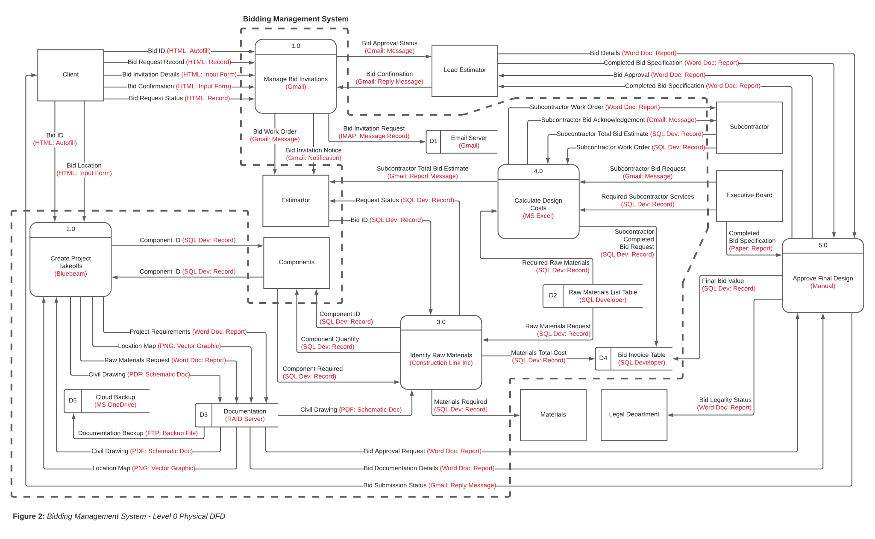

*Figure 2: Bidding Management System - Level 0 Physical DFD*

## **Section 4: Physical Data Models**

For this section, the team converted the Entity-Relationship Diagram (ERD) to a Physical Entity Relationship Diagram. The Physical ERD is a data model signifying the progression of adding information to the database. Physical ER models display all table structures such as the relationships between tables, column data type, column name, column constraints, and the primary key and foreign key. The following Physical ER diagram incorporates metadata for the tables including Varchar, Boolean, Number, etc.

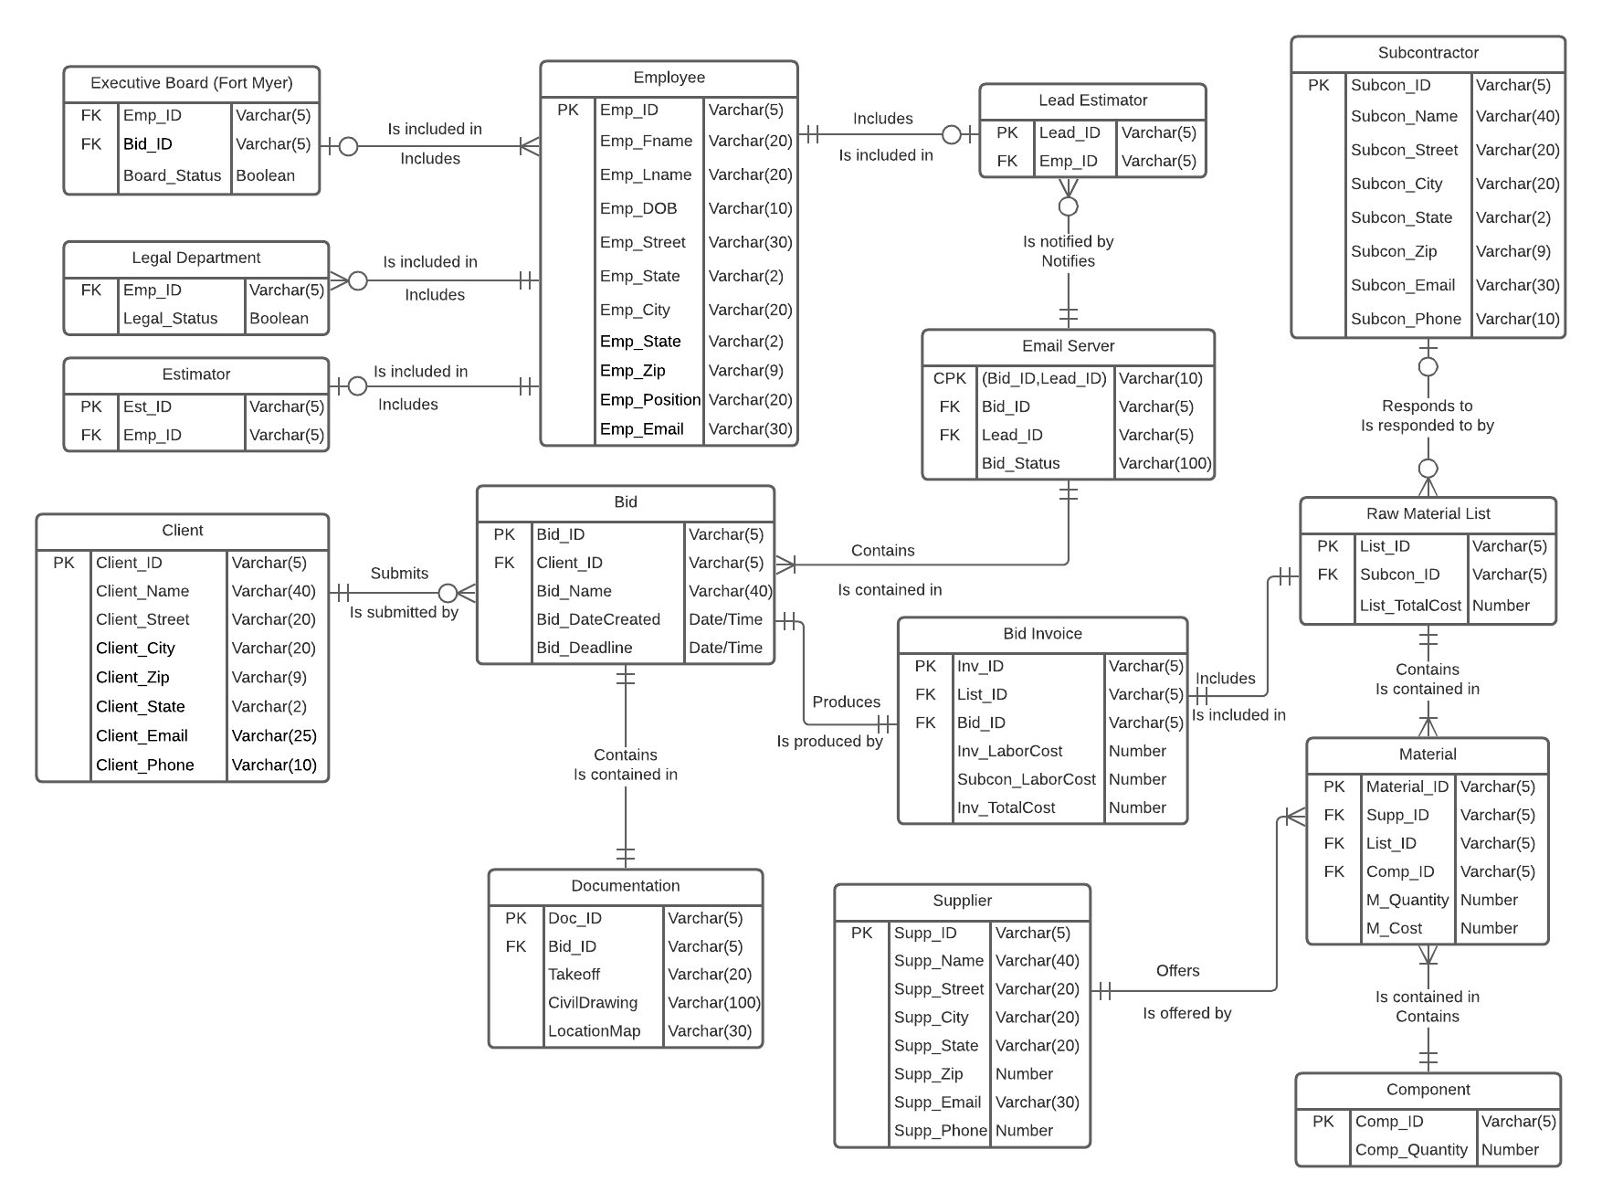

*Figure 3: Bidding Management System - Physical Data Model*